Do the OSS projects which release more often get general better sentiment score on social media?

To work on this task and provide answer on this question, several unknowns needed to be analyzed first. I needed to decide on following questions before moving on with work:

1. Which social media will be used to get data from?
2. Which OSS projects and their social media response will be analyzed?
3. Which datasets will be utilized for classifiers training?

Answer on these questions can be found in following list:

1. For this task, I will work with data from Twitter
2. To answer this question I have chosen 3 projects with different release frequency. Considered projects and their release frequency can be found in the following table:
- angularJS – 190 releases, 82 months, 2.34 releases/month
- bootstrap - 42 releases, 72 months, 0.58 releases/month
- bower – 102 releases, 60 months, 1.7 releases/month
- django – 151 releases, 64 months, 2.35releases/month – movie tweets mostly
- symfony – 291 releases, 76 months, 3.82 releases/month
- yii frameworks – 41 releases, 59 months, 0.69 releases/month
- cakephp – 289 releases, 104months, 2.77 releases/month
- gulp – 16 releases, 25 months, 0.64 releases/month
- nodeJS - 440 releases, 100 months, 4.4 releases/month
- ruby on rails - 337 releases, 113 months, 2.98 releases/month -can't get tweets
- vuejs – 209 releases, 45 months, 4.64 releases/month
- aurelia – 86 releases, 33 months, 2.6 releases/month
- emberJS – 266 releases, 76 months, 3.5 releases/month
- laravel – 78 releases, 70 releases, 1.11

(written to date of 07.10.2017)

Other area of open source projects are cryptocurrency repositories. I've decided to examine those as well. Since these are usually used more as a store of value and not used daily, their sentiment on social media is definitely not dependent on release frequency as with web frameworks.

After calculating the average frequency of releases, I've chosen to work with nodeJS VueJS as a representative of often releasing frameworks, angularJS and Ruby on Rails for frameworks with average releasing frequency and bootstrap for “lazy” releasing frameworks. To execute the sentiment analysis, I decided to use X and Y datasets.

3. When trying to answer this question I realised it is already a part of the solution since there are various datasets types for various sentiment analysis approaches.

Sentiment Analysis
Training datasets
To train the classifiers, I used the Sentiment 140 dataset. I tried to train the classifiers on data as similar to the real usage data as possible and in such case, this meant original Twitter data labeled as positive or negative. I've found such data at http://help.sentiment140.com/for-students/. Each tweet comes with 6 different information, namely tweet's polarity (negative, neutral or positive), tweet id, date of tweet publication, query of the tweet, author of the tweet and the text of the tweet.

TextBlob
As a first option, I executed the analysis with Python TextBlob library which specializes in processing textual data and to it related tasks such as sentiment analysis, classification, translation or noun phrase extraction. Using this library, polarity and subjectivity for any input string can be easily calculated. Sentiment polarity returned by Textblob is a float value in range from -1 to 1 where positive values stand for positive sentiment and negative values for negative sentiment. Bigger the absolute value of output, stronger the sentiment is. This solution didn't need any training data or labeled dataset of positive and negative words because it already comes with trained classifiers. Downside of this approach was the need to save all known words/features by myself. After implementing Textblob sentiment analysis algorithm, I was curious how correct it actually works. I decided to run it on Sentiment140 dataset and see how good accuracy it has. Accuracy is not the best metric to evaluate classifiers on, but it's easy to understand and compute and can be used as a first quick step to get rid of bad performing models. Since returned scores are floats and my Sentiment140 tweets are labeled with just positive/negative, I had to execute a small transformation of the output. Interesting point in the transformation was handling of the zero(neutral) score. In the following table are shown several considered transformation options and from them resulting accuracy of the model.
Textblob score = 0 | Accuracy
Label as positive | 0.608944
Label as negative | 0.622649
Ignore | 0.679612

Apparent from the accurary calculations, Textblob isn't performing very well. There might be several reasons for this:
- Tweets are in general difficult to analyze because they are limited to 160 characters and therefore display sparse and noisy behavior typical for short texts. They also contain lot of various special entities like hashtags or emoticons. Therefore is expected classification performance not as high as it would be with other longer text which provide more data and sentiment
- Also, Textblob sentiment analysis comes with already pre-trained classifier. Nature of the training data might play a very big role on the classifiers performance. Training data should always be as similar as possible to the actual data the model is intended to be used on.

As a second option, I decided to train my own Tweet classifier using Natural Language Toolkit library for Python. After reading several recommendations on its performance, I decided to use Naive Bayes algorithm as a ground for my classifier. As already mentioned, utilized training data came from Sentiment140 dataset. Downside of this approach was need to store known features. Since this wasn't very convenient to work with I've decided to move towards the Sci-kit module which offers improved functionality compared to default NLT.

For the third sentiment analysis I've worked with NLTK's Sci-kit Learn module. One of important advantages working with this module is its ability to work directly with feature dictionaries instead of always transforming them to numpy arrays and also no need to keep track of known features. According to the documentation, Scikit classifiers should be more memory efficient than standard NLTK classifiers because of their usage of sparse arrays. Main classification algorithms and their perfomance on 3 basic datasets can be seen on the following picture.
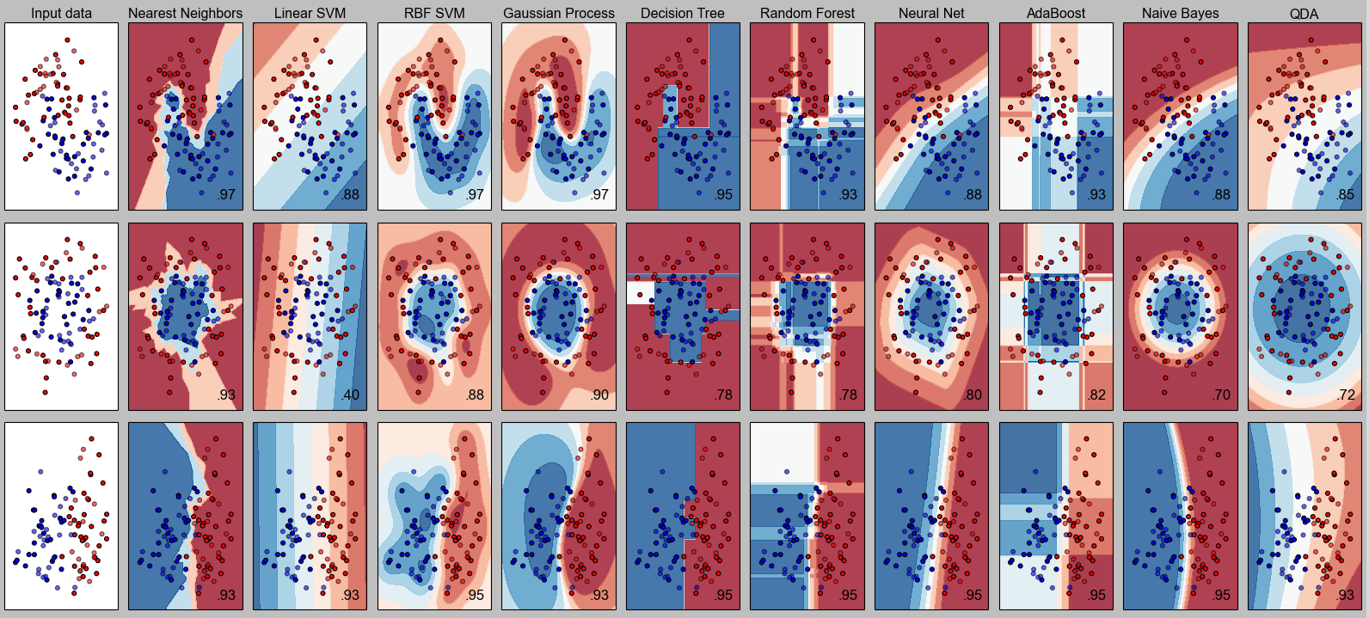
Obviously, data I want to analyze are not of numerical but rather of textual character. That means I'll have to use the classifiers which perform good with such data. According to [references], among these algorithm are listed also SVM, Naive Bayes or classical Logistic Regression so I've decided to stick with them and see how they perform and if some parameter tuning improves their performance to acceptable level. For Naive Bayes I've inspected namely Multinomial and Bernoulli Naive Bayes, since according to the Sci-kit documentation, particularly these two should be used for text classification. Expectations were high especially for Bernoulli NB, since it should perform better on shorter texts.
The datasets used to train classifiers was http://www.cs.cornell.edu/people/pabo/movie-review-data/ dataset and also Sentiment140 used for the previous classifiers with classic NLTK. With Sci-kit classifiers, I've also executed 4 fold cross-validation to ensure their performance is good enough for further usage in my thesis.
Training dataset | Test dataset | Classifier | Score (Accuracy)
Sentiment140 | Sentiment140 | Linear SVM | 0.785
 |  | Multinomial Naive Bayes | 0.761
 |  | Bernoulli Naive Bayes | 0.773
 |  | Logistic Regression | 0.797
Movie_reviews | Movie_reviews | Linear SVM | 0.849
 |  | Multinomial Naive Bayes | 0.807
 |  | Bernoulli Naive Bayes | 0.792
 |  | Logistic Regression | 0.823
Movie_reviews | Sentiment140 | Linear SVM | 0.560
 |  | Multinomial Naive Bayes | 0.562
 |  | Bernoulli Naive Bayes | 0.5
 |  | Logistic Regression | 0.515

As we can see, performance of these classifiers is much better than the previous one using Textblob. Both algorithms have several parameters which can be set to various values to increase the accuracy. Choosing the correct parameters for machine learning algorithms or so called “tuning” process is a field in itself and separate thesis could be written just about this. Sci-kit module offers “GridSearchCV” which is a way how to conveniently find the best combination of all specified parameter values. For all algorithms, I have specified several values for almost each parameter, but even the performance for returned best parameter combination performed worse than the default parameters which are used in default constructor. Even despite 78% accuracy might sound pretty low, it's important to realize that Tweets are very short text pieces which often don't offer much sentiment input to work with. Therefore is 78% quite promising performance for future work. For example, other paid services like MonkeyLearn offer 81% accuracy on Tweets sentiment classification. Just out of curiosity, I've trained the classifiers on movie reviews and evaluated them on tweets. As expected, their performance was significantly worse, which is caused by major difference in nature of training and testing data. Training data should always be as similar as possible to the actual analyzed data. Based on this now proven rule, I decided to drop all the work with movie reviews dataset and concentrate on just data similar to my use case.
Another thing I tried to increase the accuracy of the classifiers was preprocessing. (just words with letters,everything else ignored)
Rules | Classifier | Accuracy
- Just words with letters | Linear SVM | 0.785
 | Multinomial Naive Bayes | 0.760
 | Bernoulli Naive Bayes | 0.772
 | Linear Regression | 0.796
- Stripped URLs, punctuation, usernames, alphanumetric characters  - hash sign removed from hashtags | Linear SVM | 0.786
 | Multinomial Naive Bayes | 0.766
 | Bernoulli Naive Bayes | 0.774
 | Linear Regression | 0.795

At this point I've optimized 2 of tree stages of my tweets classification. I've optimized the parameters of classifiers as well as preprocessed the analyzed data. Last step which could boost the performance is actual feature extraction. In Sci-kit, TfidfVectorizer is used for this tasks. To test which parameters perform the best, I once again used “GridSearchCV” which evaluates the performance of all combinations of provided parameter values. After combining all possible combinations of specified parameters and values, 92 vectorizers have been tested. Sadly none of these vectorized data corpuses better that the one with default values. That made me use the default vectorizer values.

Negative tweets
At this point, after all the tuning, optimizing and cross-validation, I could finally run my analyzer on the testdata also provided by Sentiment140. Compared to the training data which contain just positive and negative tweets, test file contains also neutral ones. Obviously, this is a problem, since my classifiers are not familiar with the concept of neutral tweets. In current state, accuracy on a test set with neutral tweets is just 58.4% whereas on the same test set with excluded neutral tweets, accuracy was more than 81% - which is expected because similar values have been shown also during cross-validation.

First option how to introduce recognition of neutral sentiment was checking the confidence of the classifiers and define confidence thresholds for positive and negative tweets. Everything which would be between these 2 threshold levels could be considered a neutral tweet. I manually tried several values and observed following accuracy values:
Negative threshold | Positive threshold | Accuracy
0.1 | 0.9 | 0.357
0.2 | 0.8 | 0.385
0.3 | 0.7 | 0.393
0.4 | 0.6 | 0.377

As I learned out of these values, my chosen approach of labeling neutral tweets doesn't work. After this realization I was forced to change the used output of my classifiers from qualitative to quantitative. Instead of outputting just 3 classes and then assigning them values, I've decided to use those classes weighted by their confidence. Actually, in case of aliasing positive class with value 1 and negative with value 0, I realised that those weighted classes are very well represented by confidence values for positive label as well.
Often releasing frameworks:

NodeJS:
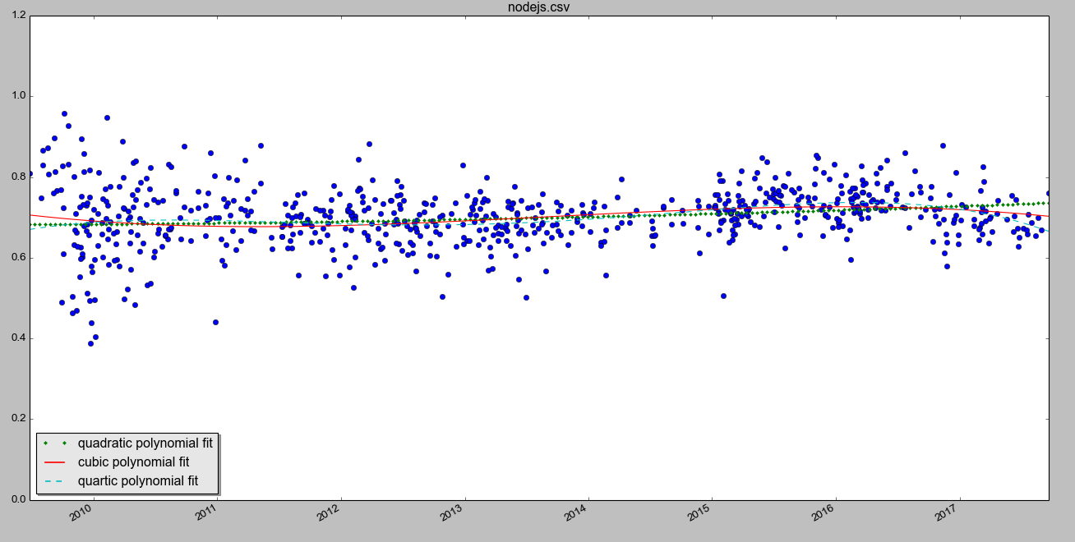
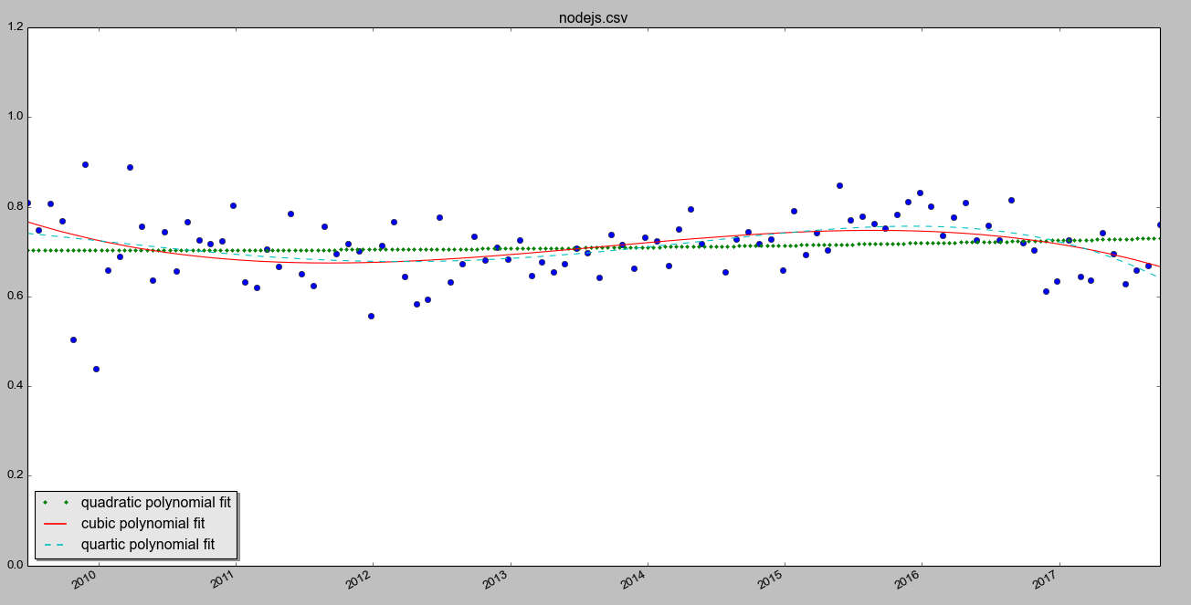

Ember JS:
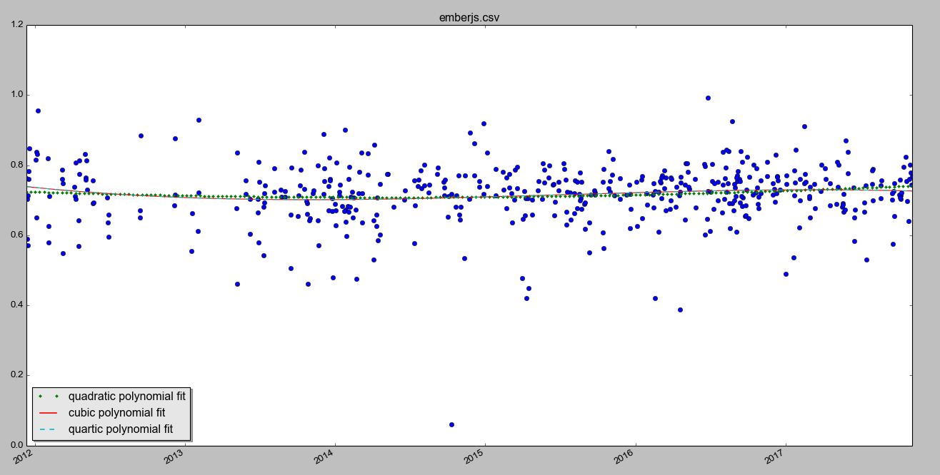
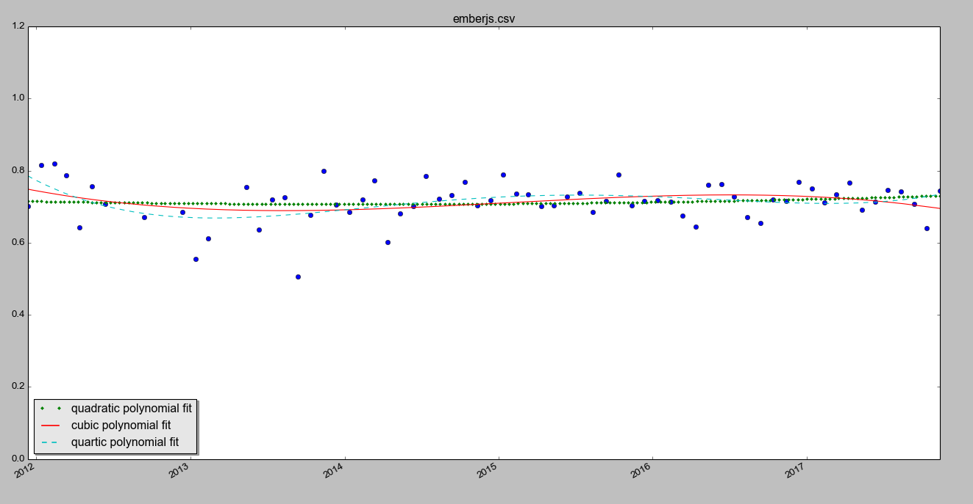

AngularJS:
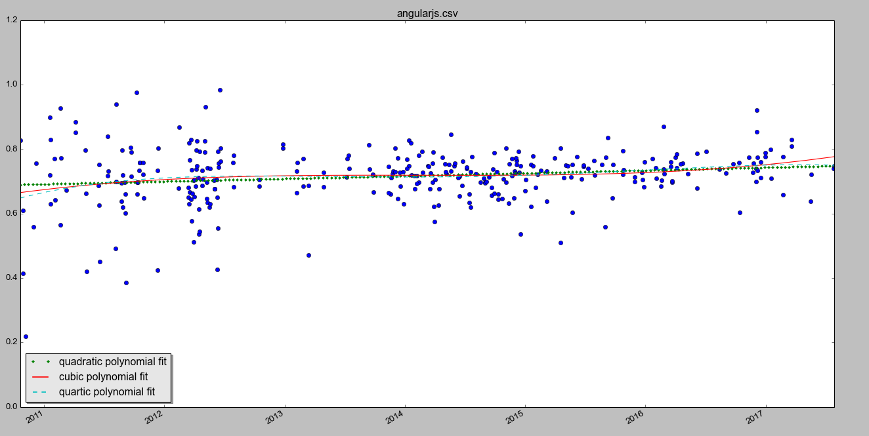
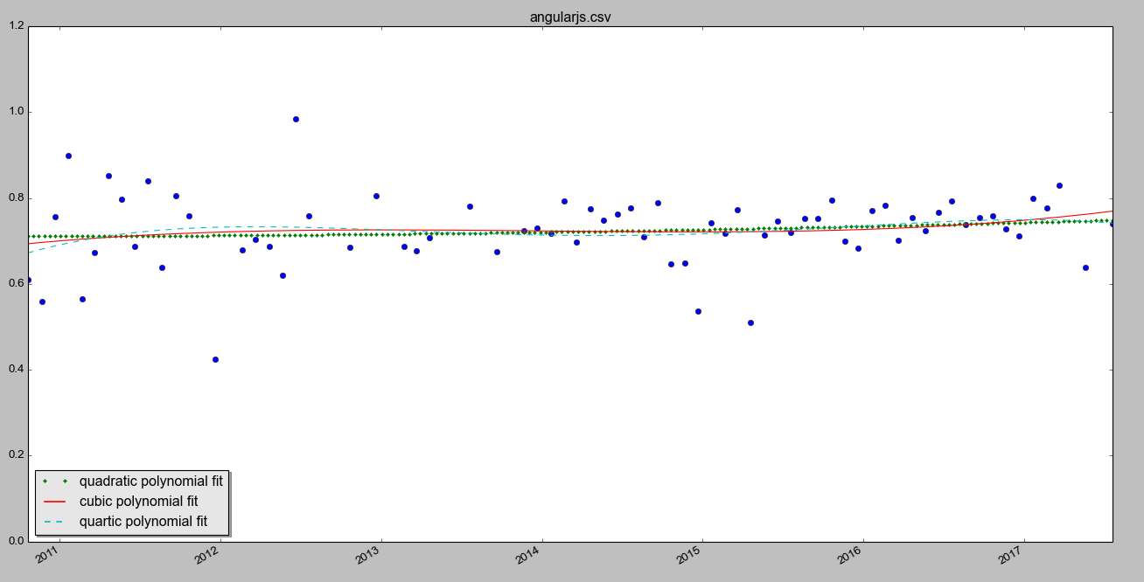

Bootstrap:
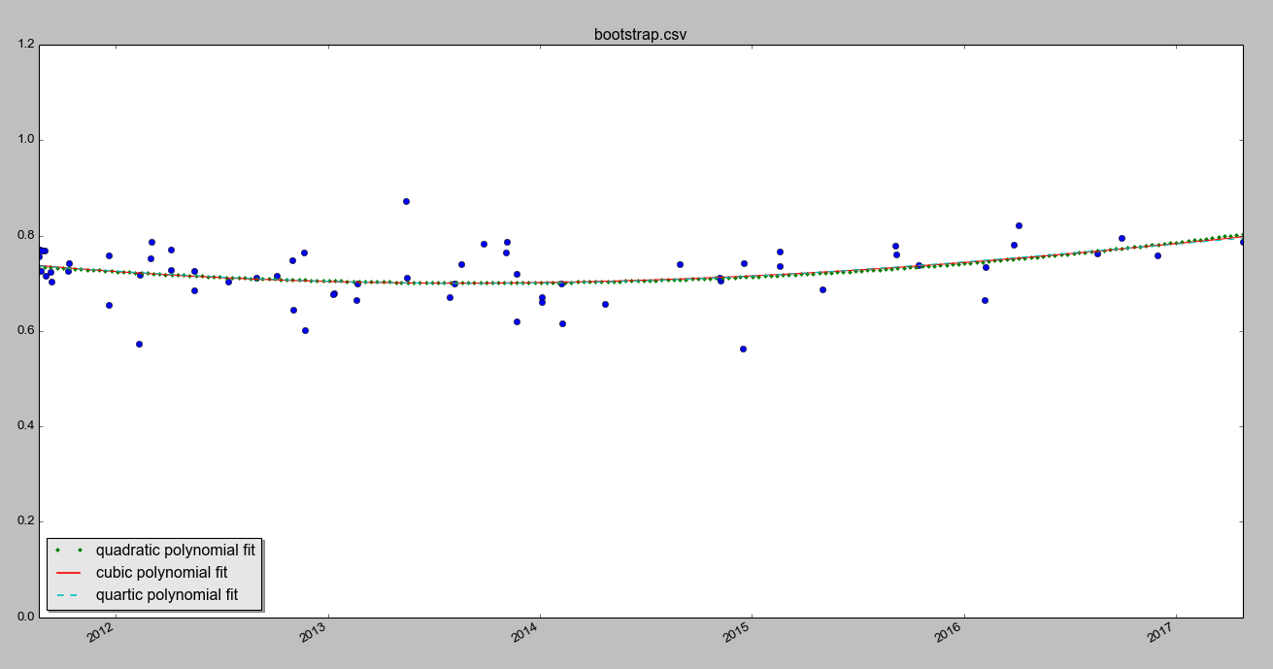
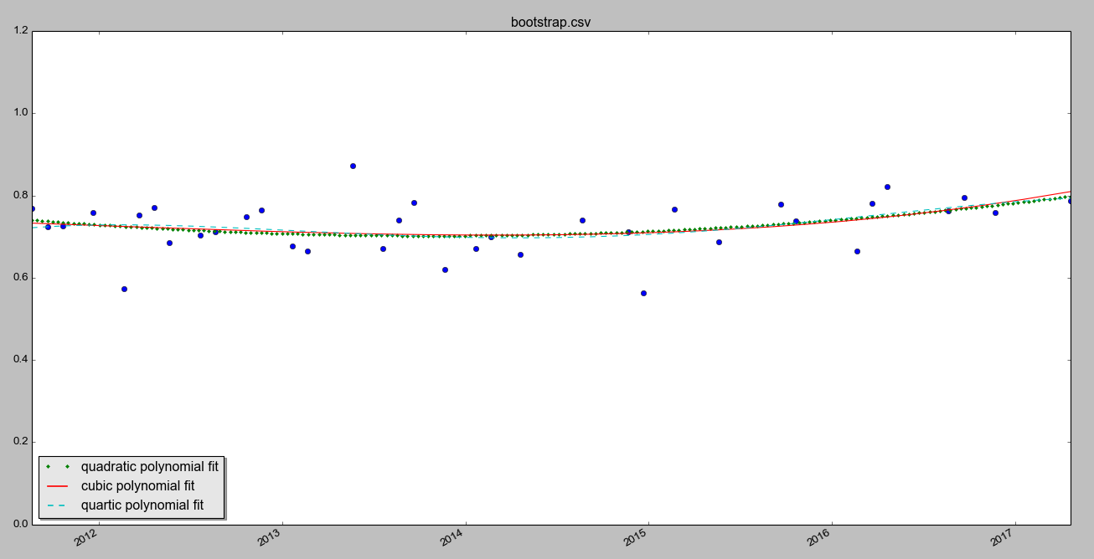

Vue JS:

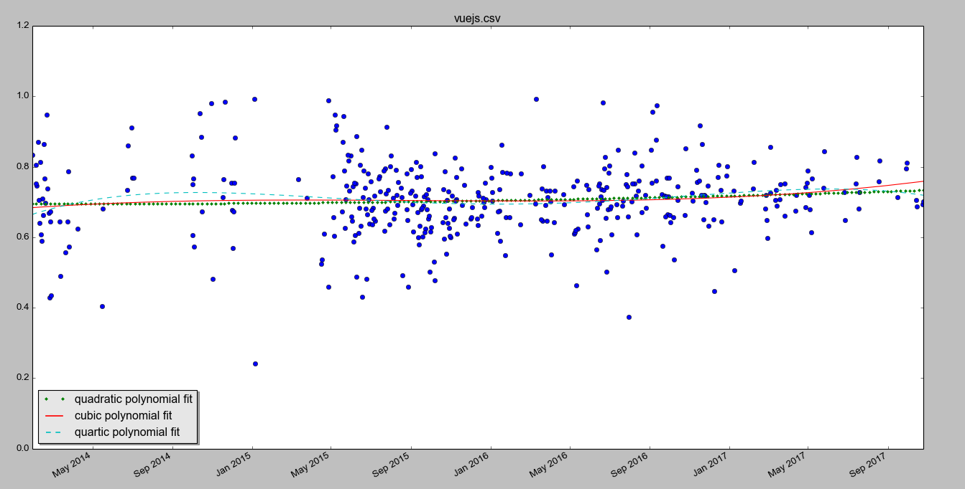
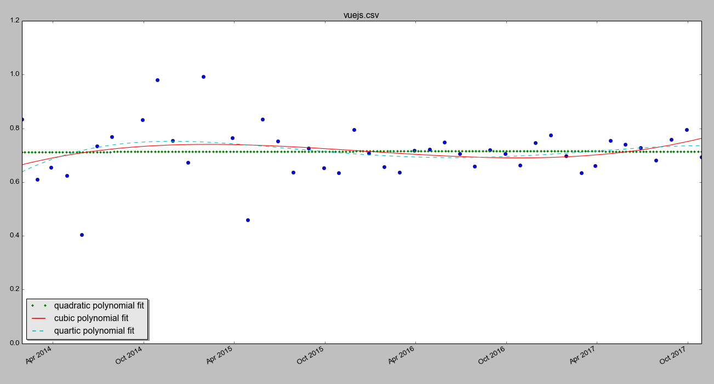

Cryptocurrencies:
Bitcoin:
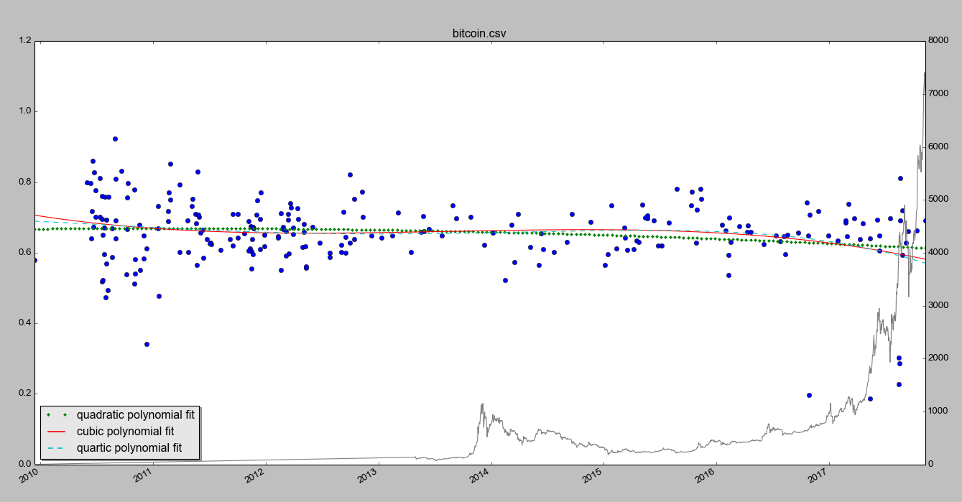
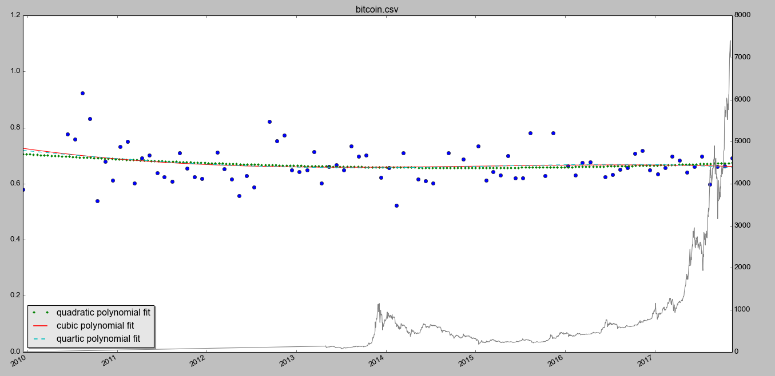

Ripple:
Ethereum:

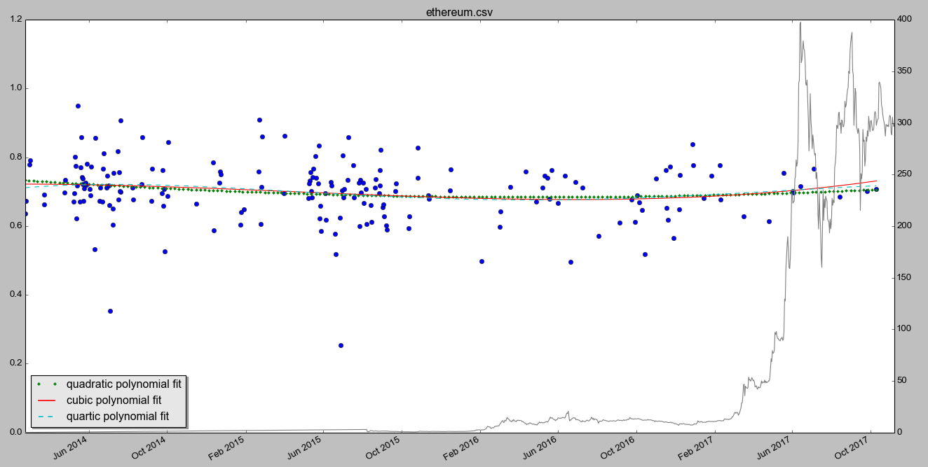

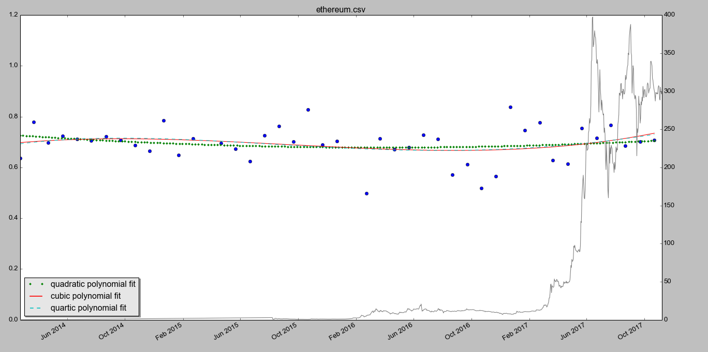

Litecoin:
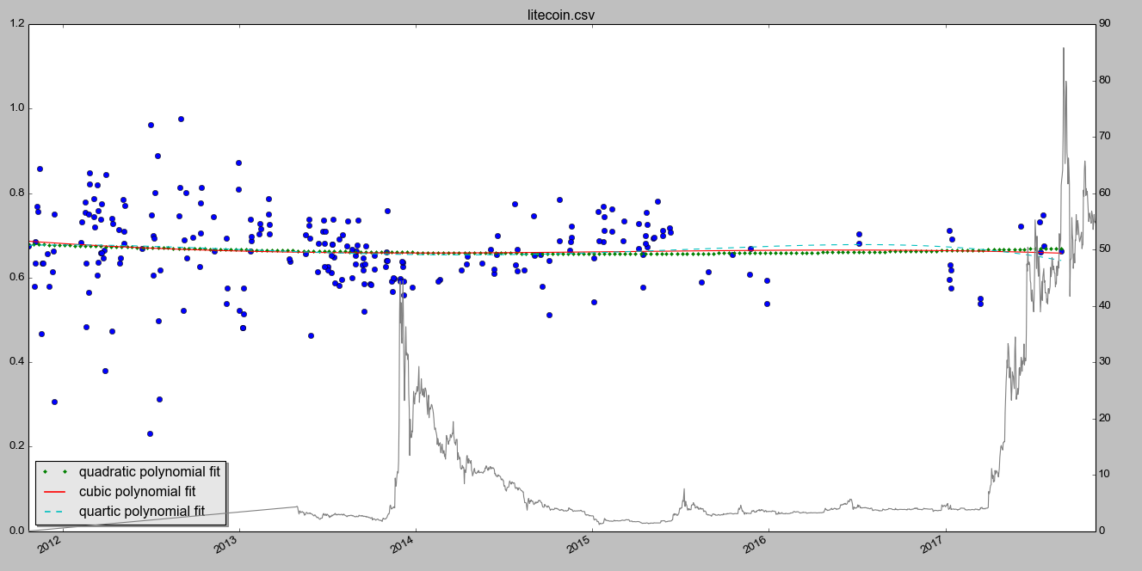
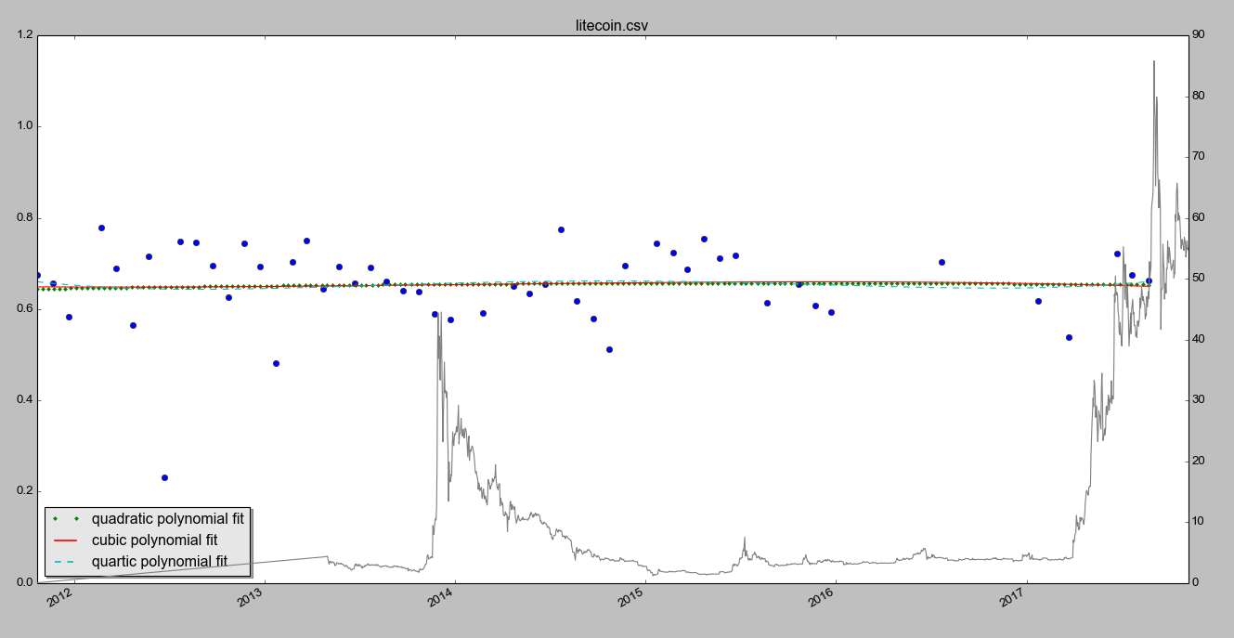

Reddit

 | Positive confidence [Twitter] | Positive confidence [Reddit]
Bootstrap | 0.720175080504 | 0.63518618369
Angularjs | 0.7274292249 | 0.618007578768
Django |  | 0.630780920759
Aurelia | 0.668628701414 | 0.648510609575
NodeJs | 0.697616596585 | 0.63398463904
EmberJs | 0.709303835768 | 0.690533285029
VueJs | 0.715662035057 | 0.60629423765
Bitcoin | 0.662906391289 | 0.517424802988
Litecoin | 0.644422227217 | 0.540911951504
Ethereum | 0.691994857095 | 0.586281793105
Ripple | 0.68091114715 | 0.580150973437

